**Amazon Needs A+**

4 key art images 135:135 + 4 texts

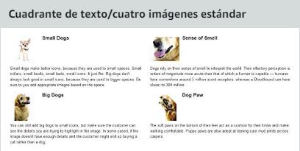

4 key art images 220:220 + 4 key features

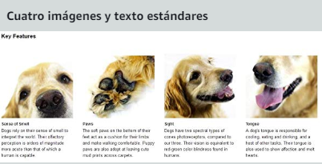

1 key art image 300:400 + 1 key art image 350:175 + 2 pharagraphs plot + text about product

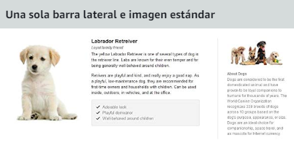

1 key art image 300:300 + key features

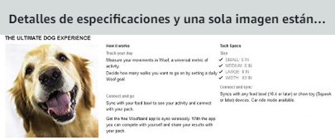

2 key art image 970:600 + key feature / game sinopsis

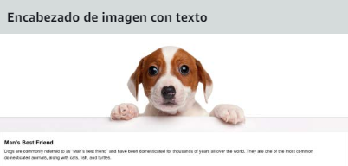

5 packshots 150:300

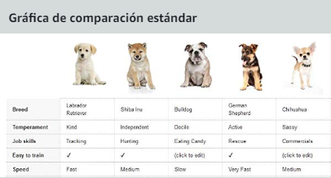

Logo image 600x180

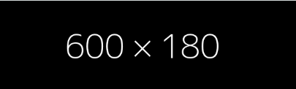

4 key art image 300:300 + game sinopsis

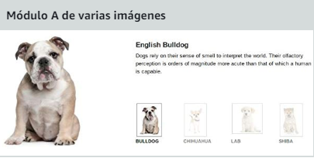

3 key art image 300:300 + 3 key features

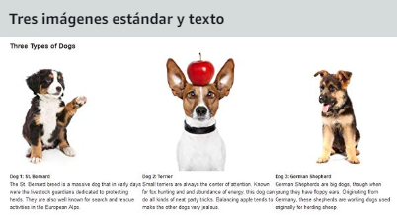

1 key art image 300:300 + game sinopsis / key feature

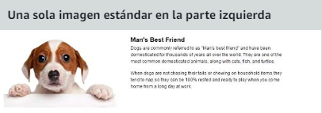

1 key art image 300:300 + game sinopsis / keyfeature

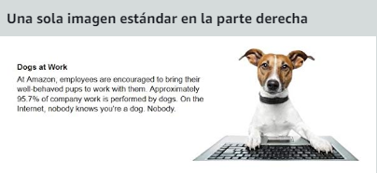

1 key art image 300:300 + game sinopsis / key feature



2 Keyarts 1920x1080

